Percentage Quantifiers

📊 What Are Percentage Quantifiers?
# Source: AI Source: Provided by: [Data Path: Persons Table -> ID Column: 1, Name_En Column: Motasem Essam] -> From: [ChatGPT] on [7/28/2025]
Percentage quantifiers express a portion or amount as a percent (%) of a whole.
They are used to show how much or how many out of 100.

✅ Common Percentage Quantifiers:
# Source: AI Source: Provided by: [Data Path: Persons Table -> ID Column: 1, Name_En Column: Motasem Essam] -> From: [ChatGPT] on [7/28/2025]
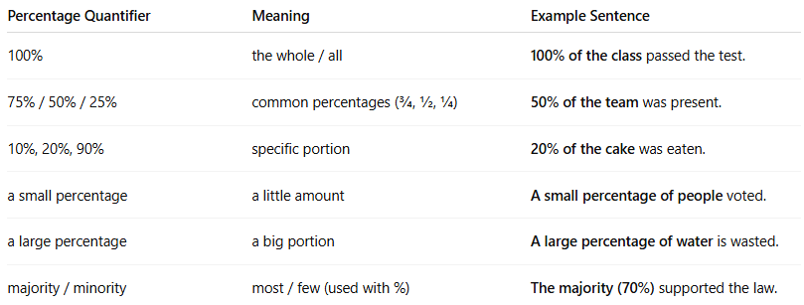
Percentage Quantifier | Meaning | Example Sentence
100% | the whole / all | 100% of the class passed the test.
75% / 50% / 25% | common percentages (¾, ½, ¼) | 50% of the team was present.
10%, 20%, 90% | specific portion | 20% of the cake was eaten.
a small percentage | a little amount | A small percentage of people voted.
a large percentage | a big portion | A large percentage of water is wasted.
majority / minority | most / few (used with %) | The majority (70%) supported the law.

🧠 Grammar Notes:
# Source: AI Source: Provided by: [Data Path: Persons Table -> ID Column: 1, Name_En Column: Motasem Essam] -> From: [ChatGPT] on [7/28/2025]
- Structure:
  - [Percentage] + of + noun
→ 70% of the population
→ A small percentage of the money
- Verb Agreement depends on the noun:
  - 50% of the cake is gone. (uncountable)
  - 50% of the apples are missing. (plural)

🔄 Related To:
# Source: AI Source: Provided by: [Data Path: Persons Table -> ID Column: 1, Name_En Column: Motasem Essam] -> From: [ChatGPT] on [7/28/2025]
- Fraction quantifiers → “half of”, “one-third of”
- Quantifiers of quantity → “most of”, “some of”, “a lot of”

